Data representation
1> https://www.techtarget.com/searchstorage/definition/byte
2> https://web.stanford.edu/class/cs101/bits-bytes.html
Video: https://www.youtube.com/watch?v=KLR5Y2uBYng

Bit, Byte, Convert Base 2 to Base 10 (Decimal)
- Computers are electronic devices that store voltages. These devices are either ON or OFF. Thus only 2 voltages are possible, 1 for ON and 0 for OFF. Thus, computer stores information (data) as two symbols ie 0 and 1.
- Data (0 and 1) is a physical concept, a raw sequence of bits and bytes stored on a computer. Data has no inherent meaning and must be interpreted by whoever is reading it. Computers store data using a sequence of 1's and 0's. Later, they read back the 1's and 0's and try to recreate the abstract concept from the raw data. Depending on the assumptions made, the 1's and 0's can mean very different things.
- What is a Bit? (The Single Switch)
  - A bit (short for binary digit) is the smallest piece of information a computer can understand.
  - A computer's brain is made of billions of microscopic electronic switches. Because a switch can only be in two positions, a bit can only have one of two values: 0 = Off (Low voltage / False)1 = On (High voltage / True)
  - A single bit cannot tell you much. It can only answer simple "yes or no" questions.
- What is a Byte? (The Character Builder)
  - Because one bit is too small to be useful on its own, computers bundle them into groups of eight. With 8 bits combined, you can create 256 different combinations of zeros and ones (from 00000000 to 11111111)
  - A byte is a group of 8 bits working together. Here is how a single byte is structured and represented. A byte consists of 8 slots. Each slot is a bit that holds a value of either 0 or 1.
 | 1 Byte
 | Upper Nibble |  |  |  | Lower Nibble
Bit position | Bit -7 | Bit-6 | Bit-5 | Bit-4 | Bit-3 | Bit-2 | Bit-1 | Bit-0
Binary number | MSB | 0 | 0 | 1 | 0 | 1 | 1 | LSB
Binary number | 1 |  |  |  |  |  |  | 0
Base-2 Place value | 1x2⁷  = 128 | 1x2⁶  = 64 | 1x2⁵  = 32 | 1x2⁴  = 16 | 1x2³  = 8 | 1x2²  = 4 | 1x2¹  = 2 | 1x2⁰  = 1
Convert Base-2 to Base-10(decimal) | 1x2⁷  = 128 | 0x2⁶  = 0 | 0x2⁵  = 0 | 1x2⁴  = 16 | 0x2³  = 0 | 1x2²  = 4 | 1x2¹  = 2 | 0x2⁰  = 0
Value(decimal) | 150
- Computers use a Base-2 (Binary) place value system,
Meaning each slot's value doubles from right to left, starting at 1.
Bit Position | 8 | 7 | 6 | 5 | 4 | 3 | 2 | 1
Place Value | 128 | 64 | 32 | 16 | 8 | 4 | 2 | 1
Bit State | 0 | 1 | 0 | 0 | 0 | 0 | 0 | 1
- Bits are numbered from right-to-left. Bit 0 is the rightmost and the smallest; bit 7 is leftmost and largest.
The "leftmost" bit in a byte is the biggest.
- Bit numbering is bit positions in a binary number. The bit number starts with zero and is incremented by one for each subsequent bit position. The value of the number is calculated by using exponentiation with the bit number and a base of 2.
- These bits are grouped as
  - Nibble (4 bits): A nibble is a sequence of 4 bits
  - 8 bits makes 1-byte byte
1101 0010
8-bits =1-byte =

  - 16 bits makes 1-word word
0000 0010 1101 0010
16bits = 1 word

  - 32 bits makes 1-double word double-word.
32bits = 1 double word
0000 0000 0000 0010 1101 0010

- Example
The binary sequence 00001001 is decimal number 9.
 | Bit 7 | Bit 6 | Bit 5 | Bit 4 | Bit 3 | Bit 2 | Bit 1 | Bit 0
binary sequence | 0 | 0 | 0 | 0 | 1 | 0 | 0 | 1
multiply by place holder. | 0x2⁷ | 0x2⁶ | 0x2⁵ | 0x2⁴ | 1x2³ | 0x2² | 0x2¹ | 1x2⁰
multiply by place holder. | 0 | 0 | 0 | 0 | 8 | 0 | 0 | 1
Decimal number | 9

- Range of 1 byte variable.
A byte can represent any whole number from 0 to 255.
00000000 = 0
01000001 = 65
11111111 = 255 (All switches on: 128+64+32+16+8+4+2+1)

Text Representation (ASCII Code)
Computers use a translation chart called ASCII (American Standard Code for Information Interchange) to map numbers to keyboard characters.
- The byte 01000001 equals 65.
- On the ASCII chart, 65 is the capital letter "A".
- The word "HI" requires two bytes: 01001000 (H) and 01001001 (I)
- One byte works well for individual characters.

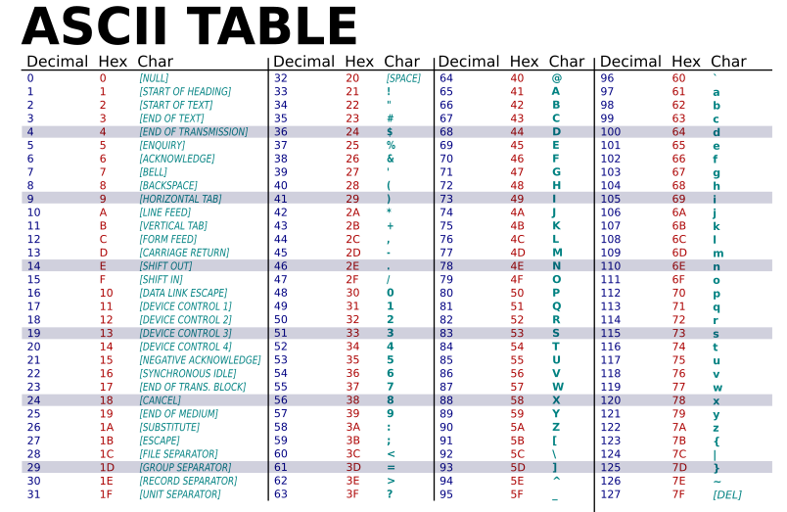

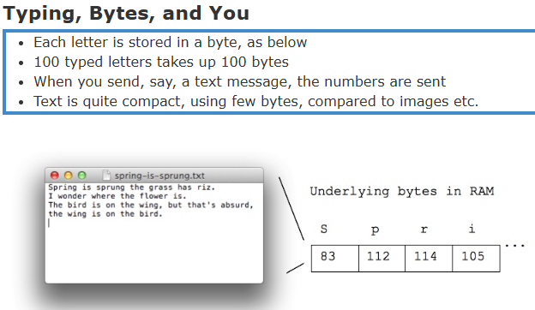 | Visualizing the Scale  To see how this grows into the files you use every day, look at how bytes multiply:  - 1 Bit: A single light switch (On or Off).  - 1 Byte (8 bits): A single letter (e.g., "H").  - 1 Kilobyte (KB, ~1,000 bytes): A short paragraph of text.  - 1 Megabyte (MB, ~1 million bytes): A 3-minute MP3 song or a high-quality photo.  - 1 Gigabyte (GB, ~1 billion bytes): A 1-hour streaming movie

